https://parentnetworkwny.org/
Parent Network offers so much – information, resources, training… Check out their website.
They have a ton of information and resources specific to Down Syndrome:  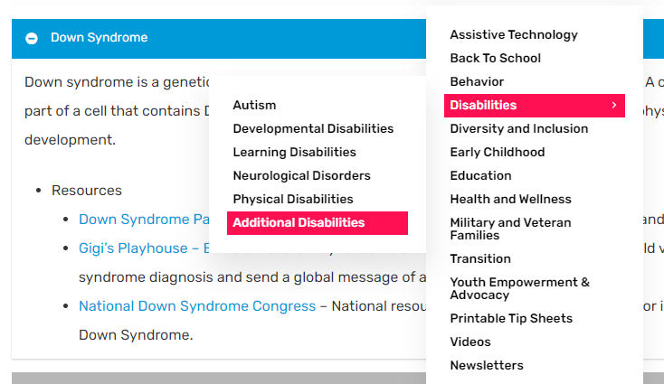  https://parentnetworkwny.org/additional-disabilities/ | They provide informaiton and assistance in applying for OPWDD Services :  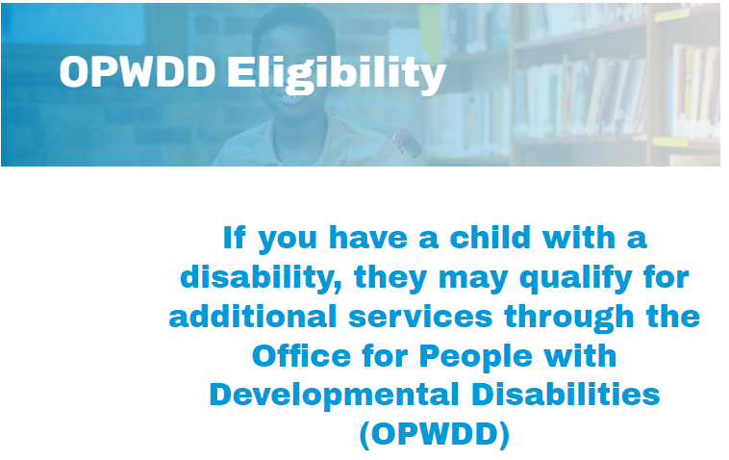  https://parentnetworkwny.org/opwdd-eligibility/
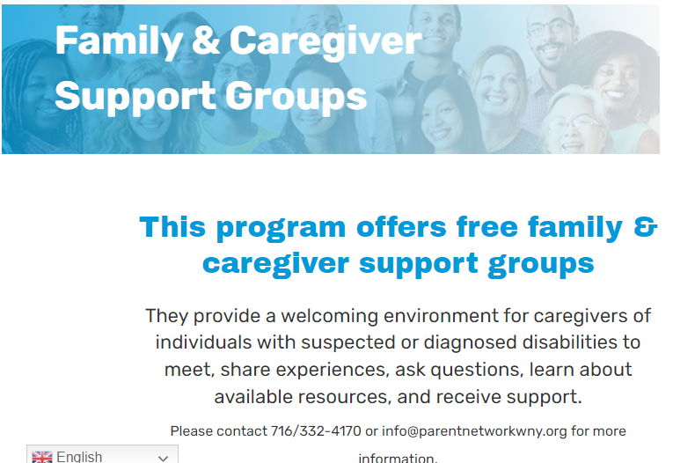  https://parentnetworkwny.org/family-and-caregiver-support/ | 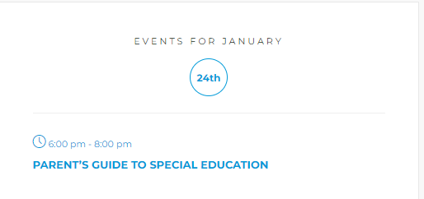  https://parentnetworkwny.org/events/

GiGi’s Playhouse Buffalo
326 Kenmore Avenue
Buffalo, NY 14223

(716) 322-0010
buffalo@gigisplayhouse.org
gigisplayhouse.org/buffalo

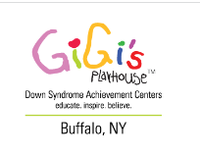

ABOUT GIGI’S BUFFALO
We began as a startup location in 2018 with a team comprised of sitting board officers from area not-for-profits, successful business leaders and entrepreneurs, educators, therapists, religious leaders, and parent advocates and activists. Over a two-year span the team raised the capital to renovate a well-known Buffalo location into a gem of a facility for the community.
Our 8000 square foot space includes a great room large enough to host group-based programs, conferences, meetings, and - with our built-in stage- performances of all types. A teaching kitchen facilitates learning about nutrition, food preparation, and life-skills. Teenagers and adults with Down syndrome form friendship circles and participate in social events including movie night, karaoke singing, and more in our Club GiGi lounge. Our adult population continues their education in the GiGi University classroom.
The Get Fit Gym is a place where individuals of all ages can participate in gross motor activities, physical therapy, fitness programs and therapeutic play while building self-confidence and knowledge of fun ways to keep their bodies active.
Our three 1-on-1 tutoring labs are practical, intimate, organized and engaging. They contain all the core materials and the latest technology necessary for literacy and math tutoring sessions.

Program Information & Schedule:
https://gigisplayhouse.org/buffalo/our-programs/

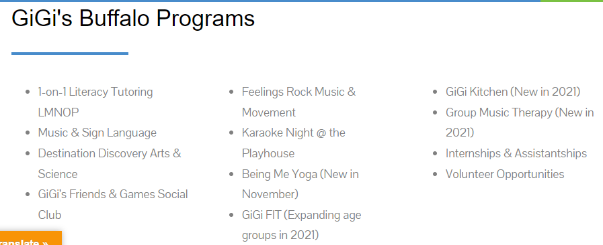

DSGPWNY!

Families. Self-advocates. Friends.
Through DSPG (Down Syndrome Parents Group), we work to raise awareness of Down syndrome while enhancing the lives of people with Down syndrome. The organization’s informational and social events provide a broad range of opportunities for families to support and encourage each other. We provide this Website as a continually expanding resource for those affected by Down syndrome in the Western New York area. Please check back often for event updates and more.

https://dspgwny.org/

