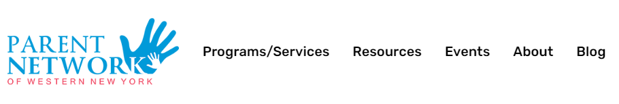
https://parentnetworkwny.org/
Parent Network offers so much – information, resources, training… Check out their website.
They have a ton of information and resources specific to Behavior Support:  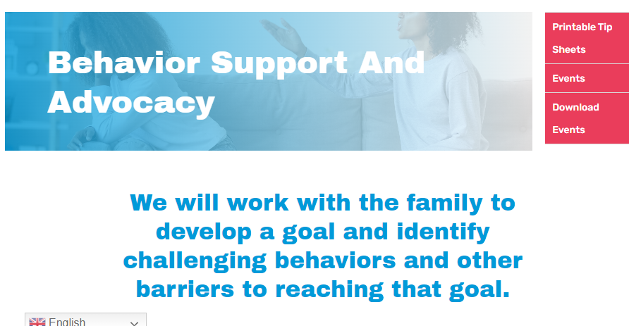  https://parentnetworkwny.org/family-behavior-support/ | 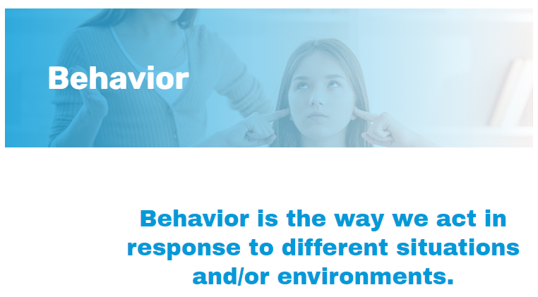  https://parentnetworkwny.org/behavior/
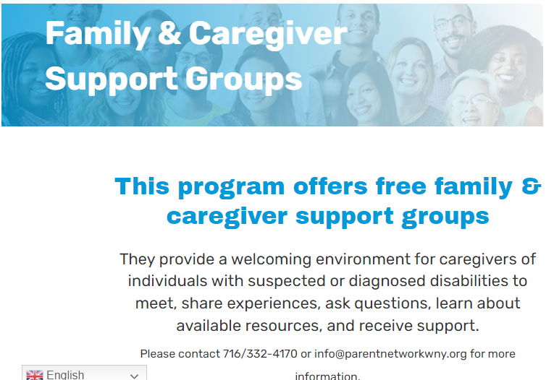  https://parentnetworkwny.org/family-and-caregiver-support/ | 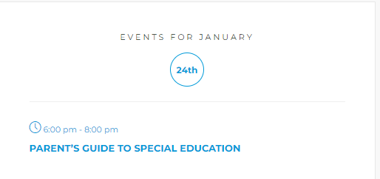  https://parentnetworkwny.org/events/

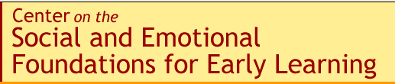

http://csefel.vanderbilt.edu/resources/family.html

Website with information and tools for families. Some examples:
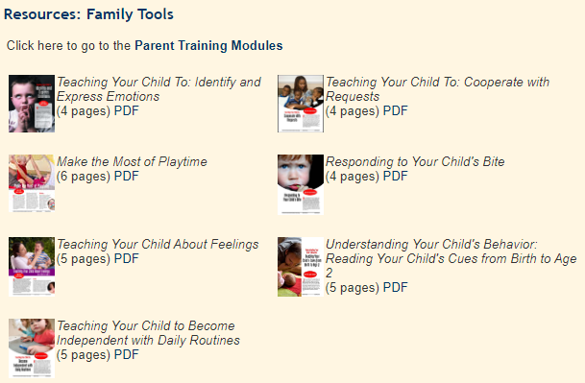
Toddlers and Challenging Behavior: Why They Do It & How to Respond
Have you ever wondered why your toddler says “no” when she means “yes” or seemingly has a melt down for no reason? Are you unsure how to respond to your toddlers strong feelings? This three-page handout provides insights into why your toddler behaves the way she does and offers strategies to help you help your toddler learn to express her feelings in more acceptable ways.
Teaching your Child Discipline and Self Control
How does your toddler develop self control? This two-page handout describes the concept of self control, provides examples of it at various stages in the first three years and offers suggestions for how to promote your child’s self control at various developmental stages.

https://www.pbs.org/parents/

A very cute website with information, strategies and games for many areas of development and age groups.
Specific to Social and Emotional skills there are topics you can choose :

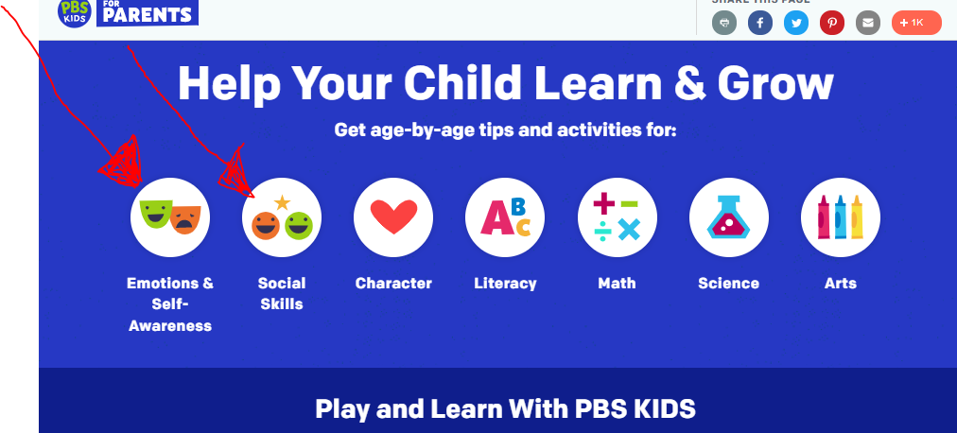

Then you are able to specify the age of your child :
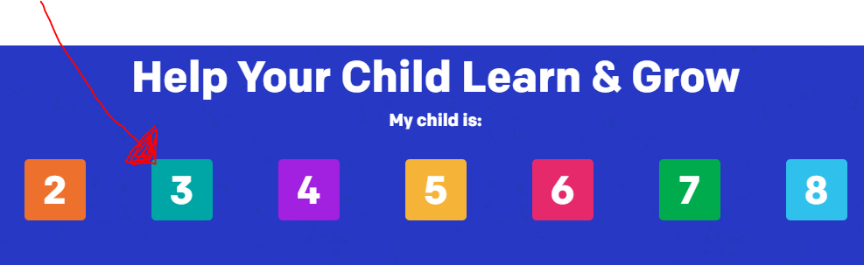

You have options for different age appropriate activities :
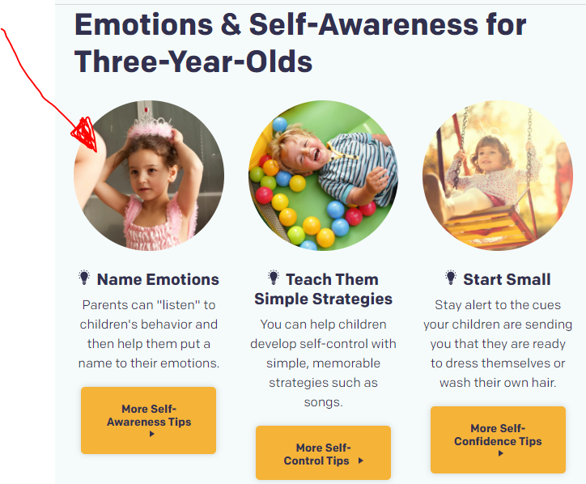
Basic information is provided :
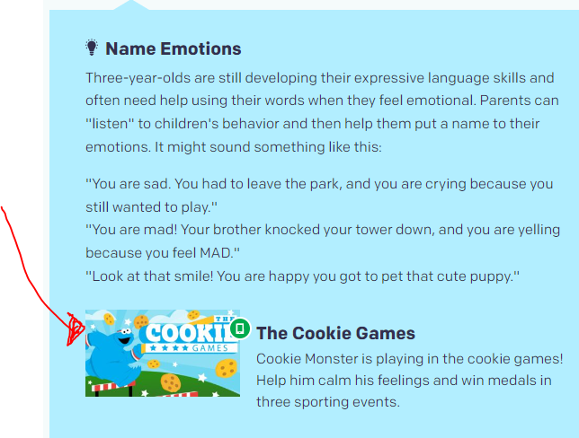
And there are interactive games you can play with your child:
